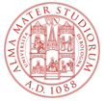

DIPARTIMENTO DI STORIA CULTURE CIVILTà  
SEZIONE DI STUDI ANTROPOLOGICI, ORIENTALI, STORICO-RELIGIOSI

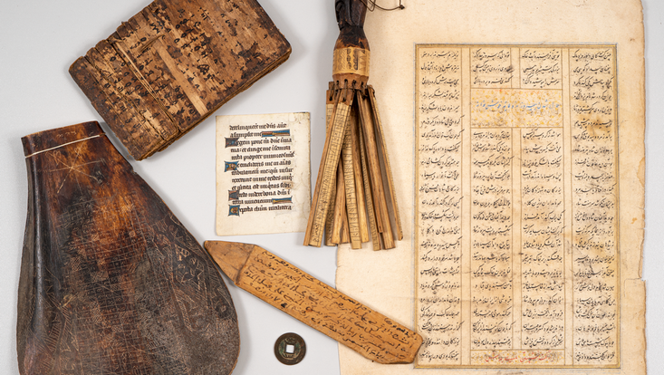

Photo: Karsten Helmholz © CSMC

**Manuscripts, Materials, Memory**

S. Giovanni in Monte, 2 - Aula Torresani

Since the late twentieth century, manuscript studies (or: manuscriptology) have become increasingly popular in the humanities. Stimulated by developments in philology (e.g. ‘New Philology’), codicology, art history and other disciplines, the field has diversified and by now includes many subjects not only from the humanities but also from the natural sciences and computer science. Up to the present day, there is still no consensus on the field’s scope and basic terminology.

The seminar I shall deliver as a visiting fellow of the MemoryLab of the Department of History and Culture (DISCI) at the University of Bologna will present an introduction to general and comparative manuscript studies, at the same time discussing manuscripts’ role in informing and mediating memory. The lectures are based on my experience at the University of Hamburg’s Centre for the Study of Manuscript Cultures (CSMC) and will present a personal synthesis of research conducted there. Following an introduction to the basic concepts of general manuscript studies, examples mainly from Asian and African manuscript cultures will be discussed, with a focus on material features. The assumption that manuscripts, and by extension writing in general, mainly served the purpose of transmitting texts, thus co-creating and stabilizing the ‘cultural memory’, will be put in perspective by examining various functions of manuscripts and the place of written artefacts in social or collective memory.

The seminar consists in four sessions of two hours each. Each session will begin with a lecture on pertinent issues, followed by a second part that will serve to discuss one to three texts which will be distributed in advance and should be read by the participants. For tuning in to the topic, I recommend Malachi Beit-Arié, *Hebrew Manuscripts of East and West: Towards a comparative codicology* (The Panizzi Lectures 1992), The British Library 1993. Additional references will be provided during the sessions.

The topics of the four sessions are:

1. **Taking the written artefact as starting point: Basic concepts of manuscript studies**

(12th November, 17.00-19.00h)

What is a manuscript? Already this seemingly naïve question has given rise to discussion. Using materials prepared at the CSMC and by myself, we will discuss this term as well as ‘written artefact’, ‘manuscriptology’, ‘manuscript culture’, the semiology of manuscripts as complex cultural signs, ‘book form’, ‘visual organisation’ and others. This conceptual exercise will involve a fundamental change of perspective leading to a fresh look at the ‘regional’ written artefacts each of us is working on.

2. **Producing manuscripts: The meaning of materials and material features**

(13th November, 17.00-19.00h)

In some manuscript cultures, there is little choice when producing a manuscript, for there is only one type each available of writing support, writing material and writing instrument. But even here one may distinguish more or less carefully prepared writing surfaces and varying degrees of refinement in the execution of writing. These distinctions multiply once there are choices, for example between roll and codex or paper and parchment. In addition, one may discern differences in quality and quantity (how much ‘content’ does one writing surface contain?). Beside the meaning of material features per se, we will look into the handling of manuscripts as a cultural practice, leaving material traces that become part of the written artefact and thus embody memory.

3. **Distinguishing functions of manuscripts: Beyond modern textual scholarship**

(14th November, 17.00-19.00h)

Contextualising manuscripts in their own history leads to the insight that transmission of texts is only one, albeit an increasingly important one, of their functions. The Buddhist tradition of copying sutras for generating merit is one case in point, production of textual amulets another one. We will discuss various additional cases and establish a typology of non-textual functions of manuscripts, mostly depending on their ‘content’.

4. **Assessing the role of manuscripts in shaping collective memory; case study: East Asian calligraphy and modern authors’ autographs**

(15th November, 17.00-19.00h)

Although distant in terms of time and space, two types of manuscripts in fact share many features, namely the East Asian tradition of the art writing (‘calligraphy’) and modern Western authors’ and composers’ autographs. In both cases, the traces of the individual hand are immediately understood as related to the person it belongs to. Thus, it becomes an artefact representing that person even after they have died, similar to a relic.

Attività valida per il conseguimento dei CFU seminari per i Corsi di Laurea Magistrale in:

Antropologia culturale ed etnologia, Global Cultures, Religioni Storie Culture, Scienze storiche e orientalistiche,

e per il Corso di Dottorato in:

Storie, Culture e Politiche del Globale

Docente responsabile:

Giovanni Ciotti (giovanni.ciotti2@unibo.it)